**A Novel Model using ML techniques for Clinical Trial Design and Expedited Patient Onboarding Process**

**Abhirvey Iyer**

Indian Institute of Technology (BHU) Varanasi INDIA

&

**Sundaravalli Narayanaswami**

Indian Institute of Management Ahmedabad INDIA

(Corresponding Author Email: sundaravallin@iima.ac.in)

**Abstract:**

In this paper, we propose and present a novel model using machine learning for an improved clinical trial (CT) design. As inquisitive researchers with an application mindset, our literature survey revealed that no previous research employed a targeted site selection of drug action and a concerted attempt to streamline patient enrolment. We developed our CT design incorporating new techniques for site selection of drug action and shortlisted patient enrolment, which are the significant contributions of our research. We collected and analysed data from 273,254 terminated or completed studies obtained from the ClinicalTrials.gov site; a test bed of global representative 55,000 samples was drawn. Employing feature engineering, ensemble learning, and the tf-idf technique, we achieved a balanced accuracy score of 71% and an Area Under the Curve (AUC) of 0.70, in determining the outcomes of CT which further enhances the site of action selection process. To expedite patient enrolment, we used a targeted selection of patients with a specific medical ailment, which in this work is liver conditions. Our results have a 73% test accuracy, which is promising for automating and optimizing patient enrolment process in clinical trials. The model proposed and presented in this paper empirically addresses the problem of low accrual rates and enrolment efficiency in clinical trials, and our results are presented.

**1. Overview**

In this paper, we present novel research that leverages machine learning (ML) models and techniques to automate the outcome prediction of clinical trials. Our study is motivated to improve the selection process of site of action for a new drug, which is not addressed in published literature, available so far, on clinical trials. By improving the target site selection process, the probability of successful completion of clinical trials increases with minimum system time and spent resources **[1]** of pharmaceutical companies and researchers, in addition to improved safety of patients enrolled in the trials.

The model presented in this paper also attempts to streamline the patient enrolment process in a clinical trial; by streamlining the patient enrolment process, clinical trials are targeted for a successful completion, minimizing the number of terminations. Global statistical analysis of all terminated trials within clinical trials database reports that 55% of trials are terminated due to a single reason of *low accrual rate*, with a highest probability. The average enrolment efficiency is also reported to be <40% for Phase III and IV trials **[2]**. The model proposed and presented in this paper empirically addresses the problem of low accrual rates and enrolment efficiency in clinical trials, and our results are presented.

To establish a robust test bed, we collected and analysed data from 273,254 terminated or completed studies obtained from the ClinicalTrials.gov site. This dataset served as the foundation for constructing a test bed of 55,000 samples, encompassing trials conducted across nations such as Australia, Canada, India, France, USA, UK, Switzerland, among others. Employing feature engineering, ensemble learning, and the tf-idf technique, we achieved a balanced accuracy score of 71% and an Area Under the Curve (AUC) of 0.70, in determining the outcomes of a clinical trial which further enhances the site of action selection process.

Finally, to streamline patient enrolment, we acquired a dataset consisting of information from 600 patients, focusing specifically on liver disease conditions. Within this context, we employed ensemble learning, feature selection, and artificial neural networks to develop an algorithm to assess patient eligibility for clinical trials targeting exclusively on liver-related ailments. Bespoke eligibility criteria were incorporated in the algorithm, enabling an efficient eligibility determination of patient records. Our results are impressive, if not promising, with a 73% test accuracy, in showcasing its potential for automating and optimizing the patient enrolment process in clinical trials.

**2. Introduction**

Clinical trials are scientific studies conducted to assess the safety, effectiveness, and potential side effects of new drugs, treatments, or medical interventions in humans. They are essential for advancing medical knowledge, improving patient care, and obtaining regulatory approvals for new therapies. Clinical trials involve carefully designed protocols, rigorous data collection, and analysis to evaluate the benefits and risks of investigational interventions. They typically follow specific phases, starting from testing in a small group of volunteers and progressing to larger populations. The outcomes of clinical trials contribute to evidence-based pharma-care and are instrumental in driving healthcare advancements.

Clinical Trials can be broadly be divided into 2 categories, Observational and Interventional trials**[3]**.

Observational trials involve the observation and collection of data from individuals in real-world settings, without any intervention or modification of their treatment. These studies aim to understand the natural course of diseases, identify risk factors, determine prevalence rates, and explore associations between variables. Observational trials rely on existing data or prospectively collect data over a specific period, using methods such as surveys, medical records, or registries. They can provide valuable insights into disease patterns, treatment outcomes, and potential adverse effects.

Interventional trials, on the other hand, involve actively intervening or assigning different interventions to participants in a controlled and systematic manner. The primary objective is to evaluate the safety, efficacy, and optimal use of new drugs, treatments, or medical interventions. These trials follow carefully designed protocols, including randomization, control groups, and blinding, to minimize bias and establish causality. They are typically conducted in multiple phases, starting from small-scale safety assessments and progressing to larger-scale efficacy evaluations involving diverse populations.

**3. Background**

The successful development of new drugs relies on rigorous clinical trials that evaluate their safety, efficacy, and optimal site of action of drugs. However, to the best of our knowledge, there is no published literature on ML being used in clinical trials to incorporate ease of target site selection of drugs and improvise patient onboarding processes. Pharmaceutical companies and researchers often encounter difficulties in identifying the near-exact site of action for new drug molecules; and resort to relying on empirical knowledge and traditional approaches that may not always yield optimal results. This often leads to suboptimal therapeutic outcomes, wasted resources, and potential safety concerns for patients. Recognizing the significance of comprehending pharmacokinetics(study of how a drug is absorbed, distributed, metabolized, and eliminated by the body. It examines the processes that influence the drug's concentration in the bloodstream over time, as well as its movement and interaction within various tissues and organs)at the site of action and providing concrete evidence of target engagement is crucial not only for scientific purposes but also for enhancing the effectiveness of pharmaceutical research and development **[4]**. Determining the success or failure rates associated with the site of action in previous clinical trials is crucial information that pharmaceutical companies typically possess, even before initiating new trials. While it is acknowledged that the reasons for trial failure are multifactorial, understanding the historical performance of the site of action provides valuable insights and ensures realistic expectations for future trials. By assessing the track record of specific sites of action of drugs using comprehensive datasets from reputable clinical trial databases, pharmaceutical companies can make informed decisions based on the success/failure rates observed in prior trials. This knowledge enables them to evaluate potential risks, anticipate outcomes, and improve the overall efficiency and success rates of their clinical trials.

Patient enrolment in clinical trials poses its own set of challenges **[5]**. Low accrual rates and inefficient eligibility assessment processes contribute to delays, increased costs, and, in many cases, premature termination of trials. The termination of trials due to insufficient patient participation has been reported as a significant problem, accounting for a substantial proportion of trial terminations worldwide. Failure to vigorously recruit and retain patients is also a common factor to creating a menace in clinical trials **[6]**. Moreover, manually reviewing large patient datasets to determine eligibility is a laborious and time-consuming task, further exacerbating these challenges.

These problems have persisted over the years; thus, the application of machine language, artificial intelligence and big data analytics is the need of the hour for pharmaceutical companies **[7]** . It is also the right approach to resolve the persistent challenges, as substantive historical data on premature termination and failed clinical trials are available. This research paper demonstrates the application of data analytics and machine learning / artificial intelligence (ML / AI) techniques in clinical trials. Our empirical results showcase the potential benefits for industry stakeholders at various stages, including trial planning, pre-trial preparation, and patient enrolment. By leveraging advanced analytics, ML and AI, our research presented in this paper aims to streamline patient enrolment and optimize the tedious procedures involved in clinical trials, enhancing the usefulness as a decision support system in clinical trials. The utilization of these techniques improves trial planning, protocol optimization, and patient enrolment processes, ultimately benefiting pharmaceutical companies, researchers, healthcare professionals, and patients involved in clinical trials.

**4. Related Works**

A prior study was conducted to identify the prevalent markers or factors linked to the termination of clinical trials and to develop an accurate predictive model for determining whether a trial will be terminated or completed **[8]**. This study utilized a dataset of 311,260 trials to construct a testbed comprising 68,999 samples. Subsequently, feature engineering techniques were employed to generate 640 distinct features. Through the implementation of sampling methods and ensemble learning, the research achieved a balanced accuracy of 67% and an area under the curve of 0.73 **[8]**. These results underscore the significance of employing machine learning models in clinical trial analysis. While this research paper shares a similar goal of emphasizing the importance of machine learning (ML) in clinical trials, it is important to note that the objectives of this study and the aforementioned paper diverge in their specific focuses. This paper [8] primarily centres on identifying common markers associated with trial termination, whereas our work places greater emphasis on enhancing the site of action selection process for a clinical trial by utilizing the trial's completion or termination status. Moreover, our research also prioritizes the streamlining of the patient on-boarding process.

Another previous study aimed to develop an algorithm to assess the risks of trial termination by analysing patterns in the language used to describe the study before its implementation **[9]**. Data was collected from the ClinicalTrials.gov repository, including structured data indicating study characteristics and unstructured text data providing narrative descriptions of study goals, objectives, and methods. The study proposed an algorithm to extract distinctive words from the unstructured text data, which were frequently used in successfully completed trials versus terminated trials. These distinctive words, along with structured data, were input into a random forest model. The combined approach yielded robust predictive probabilities with respect to sensitivity (0.56) and specificity (0.71) compared to a model using only structured data (sensitivity=0.03 and specificity=0.97)[9]. Our work also incorporates both structured and unstructured data but does not extensively emphasize the significance of unstructured data.

Another study proposed a machine learning pipeline to optimize clinical trial design by predicting the probability of early termination and identifying key features driving such terminations **[10]**. The study collected data from 420,268 clinical trials registered in ct.gov, focusing on 24 specific columns. Through feature engineering and ensemble methods, the research achieved a balanced accuracy of 0.7 and a Receiver Operator Characteristic Area under the curve score of 0.8. The study also utilized Shapley Additive Explanations to interpret termination predictions and highlight feature contributions **[10]**. The proposed pipeline has the potential to improve clinical trial design, facilitating the efficient delivery of potentially life-saving treatments to patients. While this study emphasizes on enrolment issues and study design criteria, our work is focuses on target site selection and streamlining patient on-boarding process.

In order to contextualize the contribution of our work, we conducted a thorough comparison with previous literature in the field. The results of this comparison are summarized in **Table 1**

|  |  |  |  |  |  |  |
| --- | --- | --- | --- | --- | --- | --- |
| **Research** | **Objective** | **Approach** | **Data size/ sampling** | **Training Methods** | **Results** | **Novelty/Contribution** |
| **[8]** | Utilize ML techniques to predict the likelihood of trial termination. | ML Classifiers, Feature Engineering, Class imbalance handling, and ensemble learning. | i) 311,260 trials from ClinicalTrials.gov were used  ii) A testbed of 68,999 samples  iii) 640 features were engineered | Neural Networks, Random Forest, XGBoost, and Logistic Regression | i) ROC-AUC: 0.73  ii)Balanced Accuracy: 0.67 | The study contributes by identifying key factors for clinical trial termination, highlighting the importance of statistics and keyword features, and demonstrates the predictive capabilities of various models, including ensemble methods, for accurate termination prediction. |
| **[9]** | To quantify risk associated with clinical trial termination using text mining. | Text Preprocessing, Feature Engineering, ML, and TF-IDF features. | i) The study utilized data from the CTTI, which consisted of around 250,000 trials  ii) The analysis focused on approximately 130,000 trials that began before May 1, 2015 | Random Forest Model | i) The combined approach showed 90% improvement over models using only structured data | The study contributes by combining structured and unstructured data to predict trial termination risk, highlighting the importance of incorporating derived terms from unstructured data. |
| **[10]** | To optimize trial design, minimize resource waste, and expedite the availability of life-saving treatments by predicting early trial termination using ML. | ML, Feature Engineering, SHAP, Threshold-based decision making, and iterative optimization. | i) A CSV version of the ClinicalTrials.gov, containing 420,268 trials was extracted | Logistic Regression, XGBoost, and Random Forest | i) ROC-AUC: 80%  ii) Balanced Accuracy: 70%  iii) F1-Score: 42% | The study contributes by enhancing prediction performance for early trial termination, and providing insightful suggestions for optimizing trial design using SHAP explanations. |
| **Proposed work in this paper** | To predict clinical trial outcomes, hence optimizing site selection and expedite patient enrolment. | ML Classifiers, ANN, ensemble learning, feature engineering, and TF-IDF technique. | i) 273,254 terminated or completed studies  ii) A testbed of 55,000 trials was used  iii) A 583 liver-patient dataset | XGBoost, Decision Trees, Random Forest, SVC, Logistic Regression, and ANN | i) ROC-AUC: 0.70  II) Balanced Accuracy: 71%  iii) Test accuracy: 73% (Patient dataset) | The study contributes by enhancing the target site selection process for a trial and expediting the patient on-boarding process. |

Table 1: Table illustrating the comparison of our work with previous literatures, our work distinguishes itself from previous literature by focusing on the unique vision of facilitating target site selection and expediting patient onboarding

**5. Contribution**

Research proposed in this study is motivated to ease the site selection of a new drug, so that the predictability of clinical trial completion is higher for both pharma companies and researchers. This is a significant new approach in clinical trial research, based on published literature. Attempts are also made to streamline and expedite the patient onboarding process by applying and benchmarking different ML models for efficacy. The main contribution of the study is as follows:

* Large scale clinical trial studies: A large data of 273,254 terminated or completed studies obtained from the ClinicalTrials.gov site**[11]** was analysed. This dataset served as the foundation for constructing a test bed of 55,000 samples; regions covered in the trials were representative across nations such as Australia, Canada, India, France, USA, UK, Switzerland, among others.
* Selection of site of action of a new drug: The distinct objective of our research paper is to simplify the site selection process for a new drug. The database **[11]** contains columns such as "Title" and "Conditions," which provide information about the site where the drug molecule will act to treat a specific condition. To convert this textual data into numerical data, the tf-idf technique was employed. The information in these columns has a significant impact on the outcome of a clinical trial, whether it is terminated or completed. By automating this process using machine learning models at an early stage of trial design, predictability of trial completion and termination is significantly enhanced. Similar to several existing studies **[8-10]**, various ML algorithms are applied for the clinical trial process and benchmarked. Numerical results of the proposed study (average balanced accuracy of 0.71 and score of 0.70 ) are comparable with the best of those in published literature; additionally results are also targeted in terms of locational accuracy, making our model more relevant for both pharma companies and researchers.
* Streamlining patient enrolment process: A dataset comprising the details of 600 patients, specific to liver related complications was collected for this purpose. Ensemble learning, feature selection techniques, and artificial neural networks were applied to develop an algorithm to evaluate patient eligibility for clinical trials focused only on liver-related conditions. By incorporating predefined eligibility criteria into the algorithm, the proposed algorithms are more proficient in analysing patient records and better in determining patient eligibility. This aspect of pre-specifying eligibility criteria has helped achieve a test accuracy of 73%, demonstrating further its potential in automating and optimizing the patient enrolment process.

**6. Methods and Materials**

**6.1) Data**

The initial dataset for our first area of focus, namely the selection of target sites by predicting trial outcomes, was sourced from ClinicalTrials.gov [**11**], a public data repository managed by the United States government. We followed the guidelines established by ClinicalTrials.gov when conducting our research and utilized a database of 273,254 trials. For our analysis, we created a testbed comprising 55,000 trials from various countries, including Australia, Canada, India, France, Switzerland, the USA, and the UK, to ensure a diverse global representation. All trials included in the testbed were either classified as "Completed" or "Terminated." The final testbed consisted of 24 columns or features that were used in our study.

The focus of our research is to use structured and unstructured data together to derive a better trial completion and termination accuracy by incorporating a site selection process in the ML models.

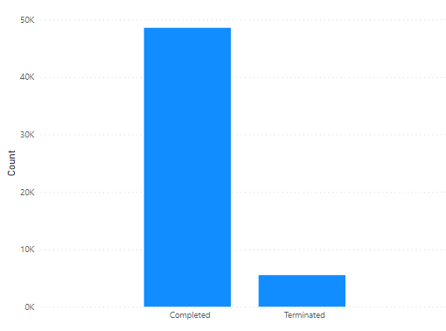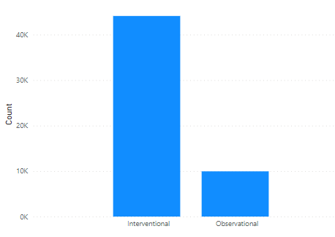

Figure 1: Number of completed trials v/s number of terminated trials in the first dataset

Figure 2: Number of interventional studies v/s number of observational studies in the first dataset

**Figure 1** depicts the number of completed and terminated trials in the testbed consisting of 55,000 samples. It provides an overview of the distribution of trial outcomes, distinguishing between those that were successfully completed and those that were terminated prematurely.

**Figure 2** illustrates the number of studies categorized as interventional trials and the number of trials categorized as observational in nature. This provides an overview of the distribution of trial types within the dataset, distinguishing between interventional studies that involve interventions or treatments and observational studies that primarily observe and collect data without intervening in the participants' treatment or conditions.

The "Title" and "Conditions" columns are essential components in our research, as they contain textual data that provides crucial information about the site of drug action. For instance, one example of a title is "Three Instructional Interventions for Prehospital Cervical Spinal Immobilization by Laypeople," accompanied by the corresponding condition "Cervical Vertebra Injury|Cervical Vertebra Fracture." In conjunction, these columns indicate that cervical vertebrae are the sites where drugs are targeted at, for an interventional condition of spinal immobility; such information is very valuable to expedite clinical termination procedures and our research attempts to codify these textual data and incorporate them into the ML algorithms.

**Figure 3** and **Figure 4** present word clouds illustrating completed and terminated clinical trials based on the text drawn from the “Title” field. These visualizations depict the relative frequency of the 1000 most prevalent words in the titles of these trials.

Similarly, **Figure 5** and **Figure 6** display word clouds for completed and terminated trials based on the text drawn from the “Conditions” field, indicating the relative frequency of the 1000 most prevalent words.

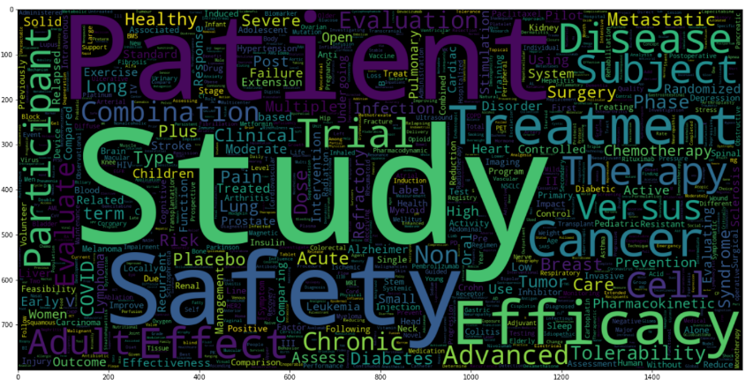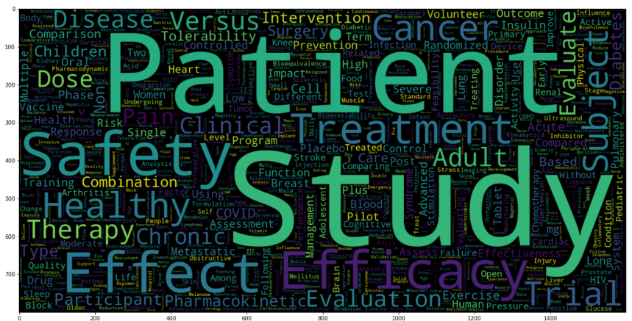These word clouds are helpful as a concise and illustrative overview of the key terms and concepts associated with the titles and conditions of the trials. It helps researchers upfront, with valuable insights on prevailing themes and trends within the conducted or discontinued studies.

Figure 4: Word cloud for terminated trials based on text found in the title field. these word clouds show relative frequency of the 1000 most prevalent words

Figure 3: Word cloud for completed trials based on text found in the title field. these word clouds show relative frequency of the 1000 most prevalent words

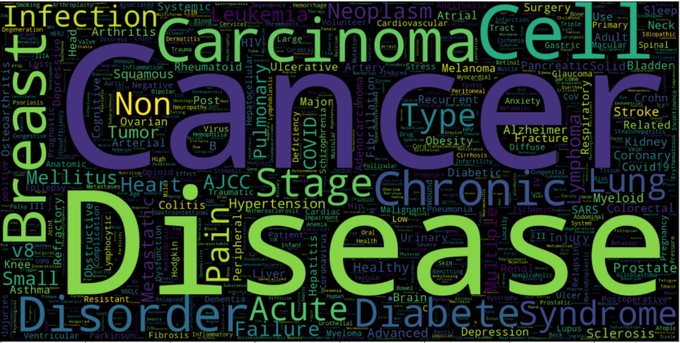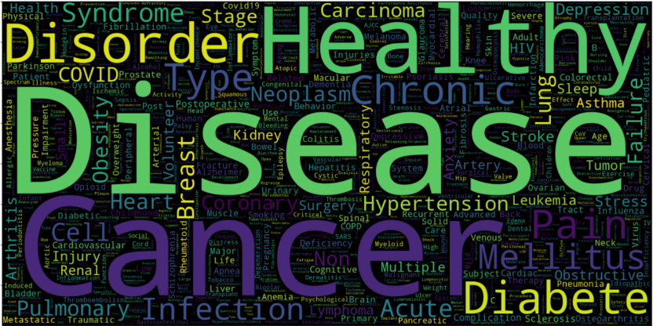

Figure 5: Word cloud for completed trials based on text found in the conditions field. these word clouds show relative frequency of the 1000 most prevalent words

Figure 6: Word cloud for terminated trials based on text found in the conditions field. these word clouds show relative frequency of the 1000 most prevalent words

The data for the second research focus, i.e., streamlining the patient onboarding process, was drawn from the University of California Irvine Machine Learning Repository **[12],** which is again a public data repository. This dataset consists of 583 individual health records, where each record corresponds to a patient’s liver condition. There are a total of 11 columns or features associated with each record. Out of the 583 records, 416 patients have been diagnosed with some liver disease while other 167 are liver healthy patient records. Our research is aimed at expediting the patient onboarding process in a clinical trial and subsequently address the low accrual rates that lead to termination of a clinical trial.

**Figure 7** provides a comprehensive list of the different reasons attributed to trial termination; the most probable and known reason for a termination trial is low accrual rate. A low accrual rate refers to an inadequate number of participants enrolment within the specified timeframe, indicating that the clinical trial completion is likely to be hindered. A high or low accrual rate is an outcome of adequacy in recruiting sample size; which can arise due to various factors such as stringency in eligibility criteria, limited patient population, lack of awareness or willingness among potential patients, higher lead time in patient onboarding, etc**[13]**.

In this research, an attempt is made to expedite the patient onboarding process, by structured analysis of various patient details through a defined set of eligibility criteria. It is observed that several columns (or features) in the dataset are significant in defining those eligibility criteria and therefore, cannot be ignored. These include "Total_Bilirubin REAL," "Direct_Bilirubin REAL," "Alkaline Phosphotase," and others. Such columns or features provide the numerical indicators of the levels of Bilirubin and other essential proteins in the liver, which further help in predicting whether a patient is affected by a liver disease or not.

Figure 7: Publicly available information on reason for termination for all terminated drug trials between 2010-2021[13].

**6.2) Feature Engineering and Feature Encoding**

Once the datasets are cleaned up for the stated objectives, the next step in the research process is to identify the optimal features or columns within the dataset. A rigorous feature selection process is employed to remove bias (redundancy) and to draw data that can enhance accuracy, integrity and reliability of the outcomes **[14]**.

The column “Study Designs” in the first dataset contains vital information related to the design of a clinical trials; if this column is split into additional columns/features with more granular data, it is hoped for better results accuracy. For example, in an “Interventional” study, the “Study Designs” column contains the following information, “Allocation: Non-Randomized|Intervention Model: Single Group Assignment|Masking: None (Open Label)|Primary Purpose: Health Services Research”, and in an “Observational” study the column contains the following information, “Observational Model: Case-Only|Time Perspective: Prospective”. Therefore, we recreate the dataset with 6 new split columns namely, “Allocation”, “Type of Intervention model”, “Masking”, “Primary Purpose”, “Type of Observational model”, and “Time Perspective”. For Interventional studies, the columns “Type of Observational Model” and “Time Perspective” are filled with “None” and vice-versa for Observational studies.

**Figure 8** displays the count of different types of interventional models used in clinical trials that involve active intervention or treatment. This visualization helps better understanding of the diverse interventional clinical trial techniques that can be employed and their relative frequency within the clinical trial landscape.

**Figure 9** presents the count of different types of observational models used in clinical trials that primarily involve observation and data collection without active intervention. This visualization helps better understanding of the different observational techniques that can be employed and their relative frequency within the clinical trial landscape.

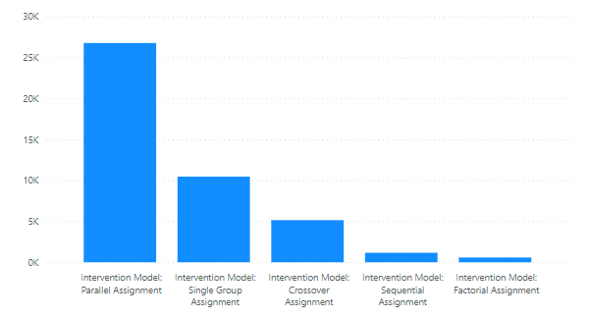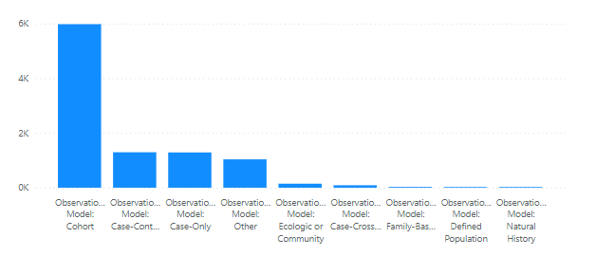

Figure 8: Count of different types of interventional models used in the clinical trials that are interventional in nature

Figure 9: Count of different types of observational models used in the clinical trials that are observational in nature

After appending relevant data in the additionally created columns, the next step is to identify textual columns, for categorization and label encoding. This process transforms the textual data into numerical representations, facilitating further computations and modelling **[15]**. Certain other columns with textual data (of frequency information) are processed through the tf-idf vectorizer method. This method calculates the term frequency-inverse document frequency (tf-idf) scores for each word in the text, capturing the significance of words in the specific document relative to the entire dataset. This transformation enables the extraction of meaningful features from the textual data **[16]**.

These selective techniques on the textual columns help effective pre-processing and conversion of data into formats suitable for subsequent analysis and modelling.

Specific to the proposed research in this paper, columns such as 'Status', 'Study Results', 'Gender', 'Phases', 'Study Type', 'Allocation', 'IModel', 'Masking',' Primary Purpose', 'Omodel', 'Time Perspective', and 'Funded Bys' are categorised and label encoded. While the remaining columns, namely 'Title', 'Conditions', 'Interventions', 'Outcome Measures', 'Sponsor/Collaborators', 'Age', 'Other IDs', and 'Locations' are converted to numerical data using the tf-idf vectorizer.

The final step, before proceeding with model development, is feature selection **[17]**. In machine learning it is very important to eliminate the redundant (and duplicate) columns/features, so as to avoid overfitting and unwanted bias. Pearson heatmap (a graphical representation of a correlation matrix using color-coded cells, where the color intensity indicates the strength and direction of the Pearson correlation coefficient. It helps visualize the relationships between variables, with dark colors indicating strong positive or negative correlations, and lighter colors representing weaker or no correlations.) is used to check dependencies between the columns and to eliminate the columns with a correlation higher than 0.8.

All columns in the second dataset have numerical data and hence, can be directly processed through feature selection.

The entire discussions above summarize the methods and procedures that were followed to complete data cleaning and to prepare the final datasets for model application.

**6.3) Model**

The usefulness of our datasets was tested using five classification models namely, Logistic Regression, Decision Tree Classifier, Random Forest Classifier, XGBoost, and Support Vector Classifier.

The first dataset which contains 55k rows is split into five small datasets each of which contains approximately, 10k-15k rows. The models are trained across these five datasets and tested. The performance of these models is evaluated using conventional metrics such as balanced accuracy score (BAS) and receiver operator characteristic area under the curve (ROC-AUC) score. Additionally, cross-validation technique is also used to compare and benchmark all the models across datasets; to help decide on which particular model is to be applied in practice **[18]**.

Class weights are set to balance in all the five ML algorithms, in order to overcome class imbalance in case of the first dataset. Under sampling is avoided, so as to prevent the loss of essential datapoints. Similarly, over sampling is avoided to prevent overfitting.

The second part of research focus, i.e., the patient streamlining dataset is additionally processed through an Artificial Neural Network for a better test accuracy.

In 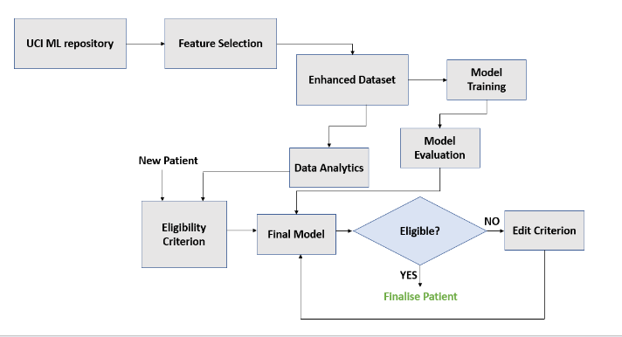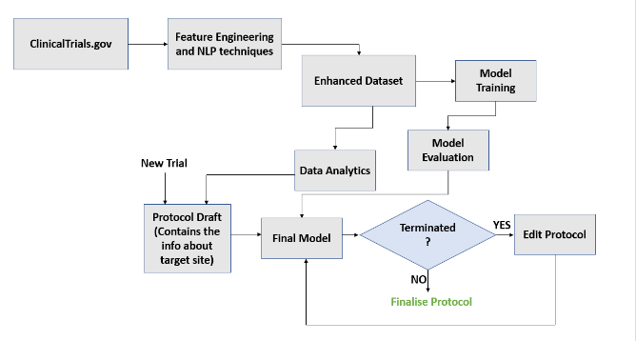**Figure 10** and **Figure 11**, the proposed model and clinical trial design of the study for target site selection and streamlining patient enrolment processes are illustrated, respectively in the form of flowcharts.

Figure 11: The proposed flow of how the mechanism will work to streamline patient onboarding

Figure 10: The proposed pipeline to ease the process of site selection

**7. Results and Conclusions**

As discussed elaborately in the precious sections, the dataset from the first part of the study has 55k samples and is now divided into five small chunks, each with around 10k-15k rows. All the ML models are trained and tested over these five chunks of data.

**Table 2** illustrates the average balanced accuracy, average ROC-AUC score, and average weighted F1-Score of the five ML models across the five small datasets.

|  |  |  |  |
| --- | --- | --- | --- |
| **ML Model** | **Average Balanced Accuracy** | **Average ROC-AUC** | **Average F1-Score** |
| Logistic Regression | 0.579558473 | 0.58 | 0.657638605 |
| Decision Tree Classifier | 0.651378029 | 0.654 | 0.857355174 |
| Random Forest Classifier | 0.658882706 | 0.662 | 0.879491915 |
| XGBoost | 0.710962 | 0.7 | 0.847450809 |
| Support Vector Classifier | 0.511502742 | 0.512 | 0.092840777 |

Table 2: Comparison of the 5 classification models based on the metrics - average balanced accuracy, average roc-auc, and average f1-score

As observed in **Table 2**, the best performance is achieved by XGBoost model across all the five datasets, with an average ROC-AUC score of 0.7 and an average balanced accuracy of 0.71. Random Forest Classifier also yields a comparable performance in all the enumerated metrics as observed in table 2.

The cross-validation(a statistical technique used in machine learning and data analysis to evaluate and validate the performance of a predictive model. It involves dividing the available data into multiple subsets or "folds". The model is trained on a portion of the data and tested on the remaining fold)scores of Random Forest are slightly better. **Table 3** depicts the average cross-validation scores of the five models.

|  |  |
| --- | --- |
| **ML Model** | **Average Cross-Validation Score** |
| Logistic Regression | 0.592 |
| Decision Tree Classifier | 0.848 |
| Random Forest Classifier | 0.8848 |
| XGBoost | 0.83 |
| Support Vector Classifier | 0.148 |

Table 3: Comparison of the 5 classification models based on average cross-validation scores

Therefore, it is summarized based on experiments, that XGBoost classifier and Random Forest Classifier are the two better performing ML models, effective with large clinical data.

The dataset pertaining to the patient streamlining process, which forms the focus of the second phase of our study, underwent classification using five models to determine the eligibility of patients for a specific clinical trial. This dataset was additionally subjected to an Artificial Neural Network (ANN)**[19]** analysis to yield the highest test accuracy of 0.73714.

In conclusion, our research highlights the significance of machine learning (ML) techniques in two critical aspects of clinical trials: the selection of the site of action for a drug and the patient enrolment process. Through the analysis of a large dataset and the utilization of five ML models, the effectiveness of XGBoost and Random Forest Classifier in accurately identifying patient eligibility for specific clinical trials is demonstrated. Empirically, these models outperformed other methods, exhibiting reliable results and robust performance, when applied to large clinical datasets.

An Artificial Neural Network (ANN) was employed, specifically tailored to handle patient data, which was used by us to demonstrate the use of ML in the patient streamlining process. The ANN analysis yielded promising outcomes, achieving a test accuracy of 0.73714, emphasizing optimization of patient streamlining process; using ANN, specific to our model.

The results of our study emphasize the importance of leveraging ML techniques in facilitating the selection of suitable drug action sites and streamlining patient enrolment in clinical trials. These methodologies offer valuable insights, improve decision-making processes, and ultimately contribute to both expediting clinical trial termination and achieving accuracy of clinical research results. As the field of machine learning continues to advance, its integration into clinical trial processes holds tremendous promise for improving patient care and driving medical innovation.

**8. Limitations and Future Work**

The research proposed in this paper has one potential imitation; only a limited number of features or design properties are used in clinical trials, which possibly restricts the depth of insights gained by our machine learning models. Including more comprehensive information, such as detailed patient conditions, could possibly enhance the models' ability to learn and achieve more accurate predictions.

Future research can focus on developing algorithms with improved interpretability, leveraging feature engineering and natural language processing techniques to extract valuable insights from textual descriptions of trials. In the context of streamlining patient enrolment, incorporating additional features, such as considering the mental stress levels of patients, could potentially lead to improved accrual rates**[20]**.

**Data availability**

As mentioned in the section 6.1 titled “Data”, our datasets on clinical trials are drawn from clinicaltrials.gov; data on patients is taken from the UCI ML repository (<http://archive.ics.uci.edu/>). Both repositories are public datasets, available for free access. These two links are also referenced in the corresponding section of the paper.

**9.** **References**

1. Sertkaya A, Wong H-H, Jessup A, Beleche T: **Key cost drivers of pharmaceutical clinical trials in the United States.** *Clinical Trials* 2016, **13:**117-126.

2. Desai M: **Recruitment and retention of participants in clinical studies: Critical issues and challenges.** *Perspectives in Clinical Research* 2020, **11:**51.

3. Grimes DA, Schulz KF: **An overview of clinical research: the lay of the land.** *The lancet* 2002, **359:**57-61.

4. Rizk M, Zou L, Savic R, Dooley K: **Importance of drug pharmacokinetics at the site of action.** *Clinical and translational science* 2017, **10:**133.

5. Carlisle B, Kimmelman J, Ramsay T, MacKinnon N: **Unsuccessful trial accrual and human subjects protections: an empirical analysis of recently closed trials.** *Clinical trials* 2015, **12:**77-83.

6. Clark GT, Mulligan R: **Fifteen common mistakes encountered in clinical research.** *Journal of Prosthodontic Research* 2011, **55:**1-6.

7. Nagra NS, Bleys J, Champagne D, Devereson A, Macak M: **Understanding the company landscape in AI-driven biopharma R&D.**

8. Elkin ME, Zhu X: **Predictive modeling of clinical trial terminations using feature engineering and embedding learning.** *Scientific Reports* 2021, **11:**3446.

9. Follett L, Geletta S, Laugerman M: **Quantifying risk associated with clinical trial termination: A text mining approach.** *Information Processing & Management* 2019, **56:**516-525.

10. Kavalci E, Hartshorn A: **Improving clinical trial design using interpretable machine learning based prediction of early trial termination.** *Scientific Reports* 2023, **13:**121.

11. Medicine USNLo: **patien.** In *Book ClinicalTrials.gov* (Editor ed.^eds.). City.

12. Bendi Ramana NV: **ILPD (Indian Liver Patient Dataset.** *UCI Machine Learning Repository* 2012.

13. Urte Fultinaviciute IM: **Trial termination analysis unveils a silver lining for patient recruitment.** *Clinical Trials Arena* 2022.

14. Jain A, Patel H, Nagalapatti L, Gupta N, Mehta S, Guttula S, Mujumdar S, Afzal S, Sharma Mittal R, Munigala V: **Overview and importance of data quality for machine learning tasks.** In *Proceedings of the 26th ACM SIGKDD International Conference on Knowledge Discovery & Data Mining*. 2020: 3561-3562.

15. Gupta H, Asha V: **Impact of encoding of high cardinality categorical data to solve prediction problems.** *Journal of Computational and Theoretical Nanoscience* 2020, **17:**4197-4201.

16. Liu C-z, Sheng Y-x, Wei Z-q, Yang Y-Q: **Research of text classification based on improved TF-IDF algorithm.** In *2018 IEEE International Conference of Intelligent Robotic and Control Engineering (IRCE)*. IEEE; 2018: 218-222.

17. Janecek A, Gansterer W, Demel M, Ecker G: **On the relationship between feature selection and classification accuracy.** In *New challenges for feature selection in data mining and knowledge discovery*. PMLR; 2008: 90-105.

18. Schaffer C: **Selecting a classification method by cross-validation.** *Machine learning* 1993, **13:**135-143.

19. Clermont G, Angus DC, DiRusso SM, Griffin M, Linde-Zwirble WT: **Predicting hospital mortality for patients in the intensive care unit: a comparison of artificial neural networks with logistic regression models.** *Critical care medicine* 2001, **29:**291-296.

20. Andersen BL, Farrar WB, Golden-Kreutz DM, Glaser R, Emery CF, Crespin TR, Shapiro CL, Carson III WE: **Psychological, behavioral, and immune changes after a psychological intervention: a clinical trial.** *Journal of clinical oncology: official journal of the American Society of Clinical Oncology* 2004, **22:**3570.